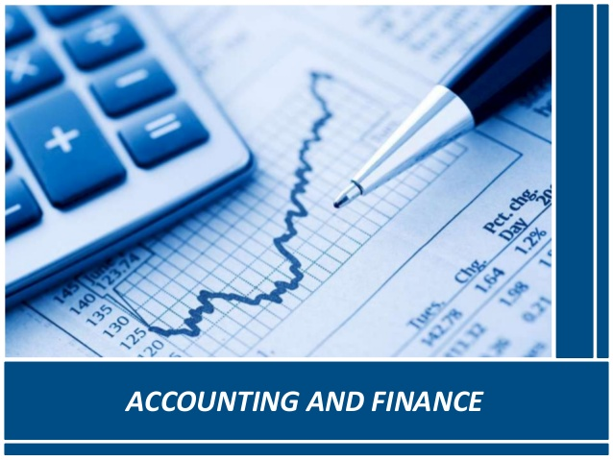

**Accounting Strategic Management**

Website: [www.btsconsultant.com](http://www.btsconsultant.com)

Email: [info@btsconsultant.com](mailto:info@btsconsultant.com)

Telephone: 00971-2-6452630

[**www.btsconsultant.com**](http://www.btsconsultant.com)

**Accounting Strategic Management**

Introduction:

Finance can add value to strategic decisions, if it is appropriately linked in to the strategic goals and objectives of the firm at corporate and business unit levels. This course demonstrates how financial analysis, planning and control processes can be integrated into the competitive and corporate strategies of the business. Financial information systems and performance measures can be adapted in order to facilitate this. This course illustrates how

The course begins with an introduction to forms of contemporary strategic practice and strategy research, and draws out the interplays between both. Rational Planning, Evolutionary, Procession and Systemic approaches are covered, and the roles of accounting within each identified. There is then a focus on recent management accounting based techniques (e.g. Direct Product Profitability, Customer Profitability Analysis) is supplemented with an introduction to the ways in which financial accounting based techniques for tracking Shareholder Value also play a role. The move to studying Strategy as Practice (what strategists do) is used as a basis for seeing how far accounting is what strategists do and the drift towards inward and outward facing organizations where all must be strategic and professional. The possibility of Strategy as Accounting is introduced as one increasing future trend.

Who Should Attend?

Senior managers with responsibility for or involvement in the development or implementation of competitive strategy, Financial managers with a close involvement in a different functional area (e.g. marketing accountants), Finance staff providing supporting information for strategic decisions

Course Objectives:

**By the end of this course, delegates will be able to:**

* Understand the nature of business strategy
* Understand and apply various Management Accounting techniques appropriate to developing and monitoring strategy, including: value - chain analysis; accounting for competitive position; costing product attributes; modern approaches to costing and cost management - especially activity based costing; processes and problems of performance measurement, including the balanced scorecard approach; the balanced scorecard as a tool for implementing business strategy
* Understand the historical development of business strategy and the roles of accounting in that development
* Demonstrate a technical grounding in recent and current approaches to using management accounting systems to support the development and implementation of business strategy
* Understand the use of strategic cost analysis and shareholder value analysis through such techniques as Customer Profitability Analysis, Direct Product Profitability and Shareholder Value Techniques
* Demonstrate a critical awareness of accounting in its organizational context, the strengths and limitations of strategic planning, and the roles of accounting within strategy formation and practice
* Apply management accounting tools and methods for strategic management by products, responsibility centers and activities
* Design performance measurement system supporting strategic, tactical and operations level of management
* Prepare management reports for strategic performance analysis and suggest steps to issues solution
* Demonstrate an insight into possible new alignments between strategy, accounting and decision-making
* Understand and evaluate potential future developments across the strategy / accounting / management interface in the light of historical and current trends
* Achieve continuing professional development (CPD) while updating their management accounting skills
* Understand the nature of modern strategic management and the roles played by accounting in both supporting and shaping it
* Develop your technical understanding of the range of ways in which accounting is deployed to achieve both supporting and shaping outcomes
* Have an insight into the way in which management accounting can add value to a business through a more positive and proactive involvement in the strategic decision making process
* Understand the way in which many financial techniques can be used strategically to enhance or evaluate competitive advantages

Course Outline:

**Introduction to & Definition of Strategic Management Accounting**

* Understanding the relations of Strategy to Accounting
* Role of strategic management accounting (SMA)
* Business performance factors and their influence on management and management accounting
* Context of traditional tools and methods of management accounting
* Relationship between management accounting and strategic management tools
* SWOT analysis
* Value chain analysis
* Portfolio analyses

**Strategic Performance Measurement**

* Basic conceptual approaches to performance measurement
* Criteria and definition
* Revenue and cost analysis for strategic management

**The Calculation of Costs and Prices**

* Target costing, establishing a target price and its relation to the pricing strategy
* Life-cycle costing (LCC), context, pros and cons
* Life-cycle contribution assessment and its impact on investment projects
* LCC and management of research and development costs

**Implementation of Strategic Management Performance Tools**

* Costing system for tactical and operational level
* Strategic, tactical and operational levels of analysis (standard costing and variance analysis)

**Activity-Based Management**

* ABM, Value/Based Management, Just-In Time, Total Quality Management
* Activity-based accounting tools: ABC, ABB, zero-based budgeting, customer-profitability analysis

**Quality Management**

* Management accounting and its relationship to internal audit and total quality management
* Quality and quality management as a corporate performance issue
* Identification and optimization of quality costs

**Management Control Systems**

* SBU performance measurement
* Centralization and decentralization from the perspective of strategic management
* Understanding the relations of Strategy to Accounting: Strategy as accounting
* Organizational structures and strategic management information support
* Balanced Scorecard Performance Management Systems, including the Balanced Scorecard
* Performance Measurement
* Management and Improvement in Service Businesses
* Strategic Management
* Risk Management
* Leadership, Change and Management Accounting